AI LOAN ELIGIBILITY CHECKER
AI-Powered BFSI Financial Decision Support Platform
Project Documentation

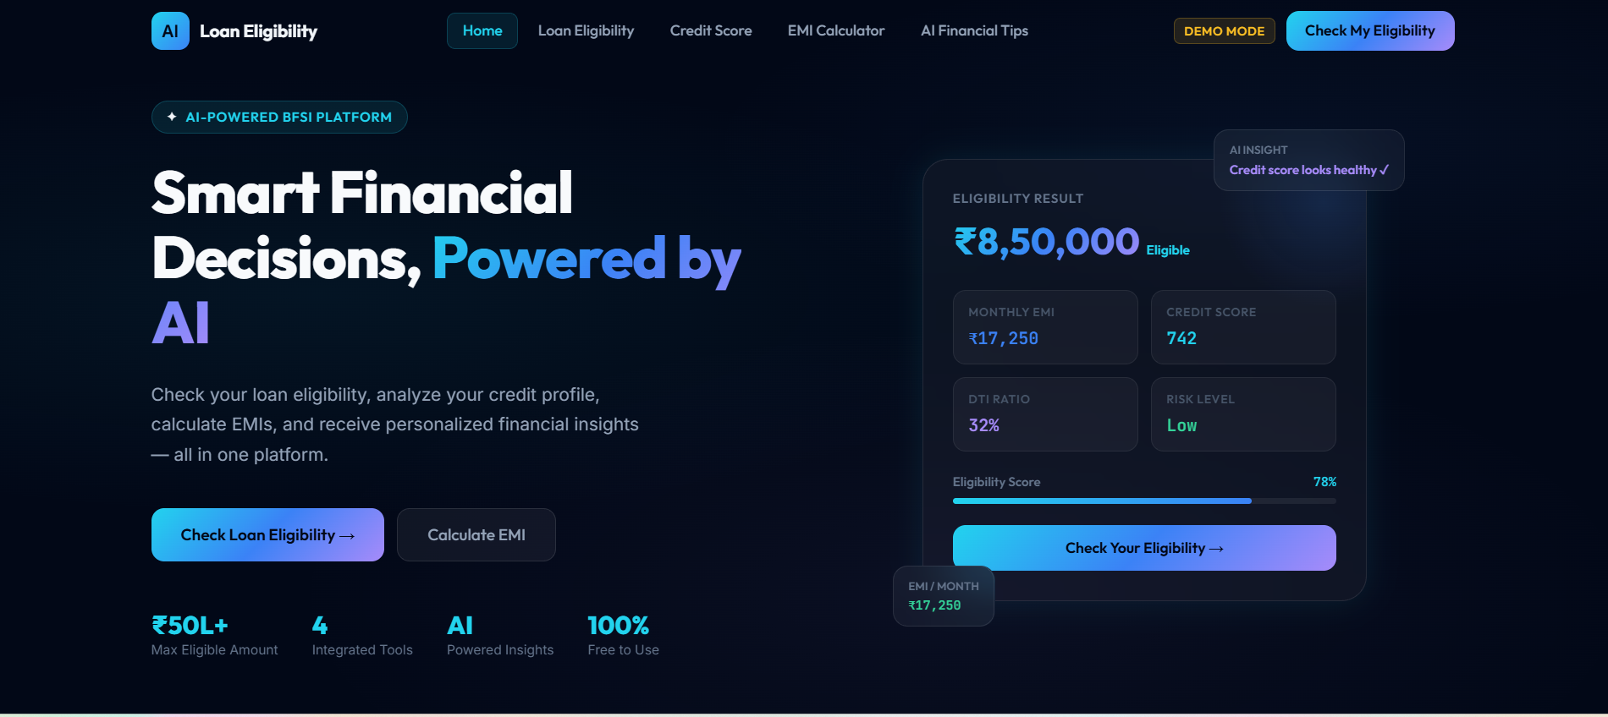
Figure 1. AI Loan Eligibility Checker – Home Dashboard
Powered by BFSI rule-based calculations, Claude AI and Google Sheets integration

Core Modules | Loan Eligibility • Credit Score • EMI Calculator • AI Financial Tips
Technology | HTML5 • CSS3 • JavaScript • Claude AI • Google Sheets
Interface | Responsive dark glassmorphism fintech dashboard
Document Basis | Project description + uploaded BFSI Final Documentation + application screenshots

Abstract
The AI Loan Eligibility Checker is an AI-powered BFSI (Banking, Financial Services & Insurance) web platform designed to simplify and accelerate personal financial decision-making. The platform combines four financial utilities—Loan Eligibility Checker, Credit Score Analyzer, EMI Calculator, and AI Financial Tips—within a single interface. The uploaded project documentation describes the system as a financial decision-support platform powered by BFSI rules and Claude AI.
The application is implemented using HTML, CSS and JavaScript and uses a modern dark glassmorphism interface with interactive cards, financial indicators, forms and dashboard navigation. Claude AI extends the application beyond fixed calculations by providing AI-generated financial guidance. The current application also includes Google Sheets integration for persistence of submitted user data, supporting transparency and continuity across sessions.
The platform is intended for educational and decision-support purposes. Loan eligibility and other financial outputs are estimates and do not represent a guarantee of approval by any bank or financial institution.

Table of Contents
- 1. Project Overview
- 2. Problem Statement and Objectives
- 3. Technology Stack and System Architecture
- 4. Core Modules
- 5. Project Scenarios
- 6. Project Workflow and Task Planning
- 7. User Interface and Screens
- 8. AI Integration and Data Handling
- 9. Testing and Verification
- 10. Results and Discussion
- 11. Limitations and Future Scope
- 12. Conclusion

1. Project Overview
FinEdge AI Loan Eligibility Checker (AI Loan Eligibility Checker) is designed as an integrated financial decision-support web application. The uploaded BFSI documentation identifies four major financial activities: checking potential loan eligibility, understanding credit health, calculating estimated monthly EMI payments, and receiving personalized AI-generated financial tips.
Instead of requiring users to move between separate calculators and financial-information tools, the platform brings these activities into one dashboard. The interface uses a dark glassmorphism visual language, highlighted financial values, interactive controls, gauges and responsive layouts.

1.1 Key Functional Areas
- Loan Eligibility Checker – accepts applicant financial information and produces an estimated eligibility result.
- Credit Score Analyzer – presents a credit score and highlights important credit-health factors.
- EMI Calculator – estimates monthly repayment from principal, interest rate and tenure.
- AI Financial Tips – uses Claude AI to provide educational and personalized financial guidance.
- Google Sheets Integration – stores relevant submitted data for persistence and transparency.

1.2 Project Description
The platform provides instant access to four core financial tools through a seamless interface. It combines rule-based BFSI calculations with Claude AI reasoning so that numerical outputs and conversational guidance can be presented together.

2. Problem Statement and Objectives

2.1 Problem Statement
Users often need to perform several basic financial checks before considering a loan: estimating eligibility, understanding credit health, calculating repayment obligations and seeking general financial guidance. Using separate tools can make this process fragmented and difficult for beginners. The proposed application addresses this usability problem by bringing these functions into one interactive BFSI platform.

2.2 Objectives
Objective | Purpose
Loan Eligibility Analysis | Provide an interactive method for entering financial information and estimating loan eligibility.
Credit Score Analysis | Help users understand their credit score and the major factors that influence credit health.
EMI Calculation | Calculate estimated monthly loan repayments from loan amount, interest rate and tenure.
AI Financial Guidance | Use Claude AI to provide personalized financial tips and planning suggestions.
Unified Financial Dashboard | Integrate multiple financial tools into one easy-to-use web platform.
User-Friendly Experience | Present complex financial information using understandable cards, indicators, gauges and visual components.

3. Technology Stack and System Architecture

3.1 Technology Stack
Technology | Role in Project
HTML5 | Semantic structure for pages, forms, navigation and dashboard components.
CSS3 | Responsive styling, dark glassmorphism cards, gradients, indicators and animations.
JavaScript | User interaction, calculations, navigation, validation and module logic.
Claude AI | AI-powered financial guidance and analysis.
Google Sheets | Persistence layer for selected user-submitted financial data.
BFSI Rules Engine | Predefined financial rules and calculations for estimates and analysis.

3.2 System Architecture
The uploaded documentation describes a modular architecture with a presentation layer, financial processing layer, AI layer and user-interface components. The frontend contains HTML structure, CSS styling, JavaScript interactions, dashboard components, forms, cards, gauges and result panels. The financial processing layer applies BFSI rules and calculations, while the AI layer provides Claude-powered guidance.
User / Browser | Enters financial information and requests calculations or AI guidance.
Presentation Layer | HTML, CSS, JavaScript UI, forms, cards, navigation and result panels.
Financial Processing | BFSI rules for loan eligibility, profile evaluation, EMI and credit-related analysis.
AI Layer | Claude AI processes financial questions and produces educational guidance.
Persistence | Google Sheets integration stores selected submitted data and results.

4. Core Modules

4.1 Loan Eligibility Checker
The Loan Eligibility Checker collects relevant applicant information and evaluates the profile according to the application's configured BFSI rules. The current interface includes fields such as full name, age, monthly income, employment type, work experience, existing monthly EMI, number of existing loans, desired loan amount, loan tenure and credit score.
The result area is designed to present an estimated eligible amount, estimated EMI, credit score, debt-to-income ratio, risk level and an eligibility indicator. The application clearly states that calculations are estimates and that actual eligibility is determined by the bank.
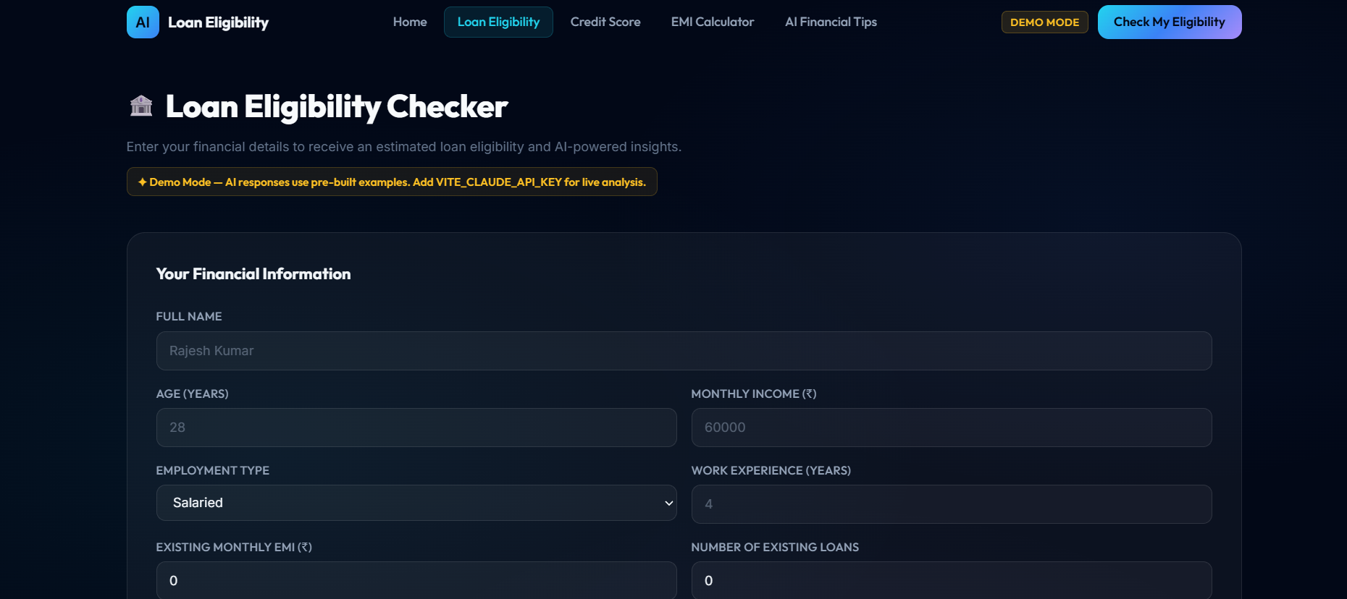
Figure 2. Loan Eligibility Checker – Applicant Financial Information
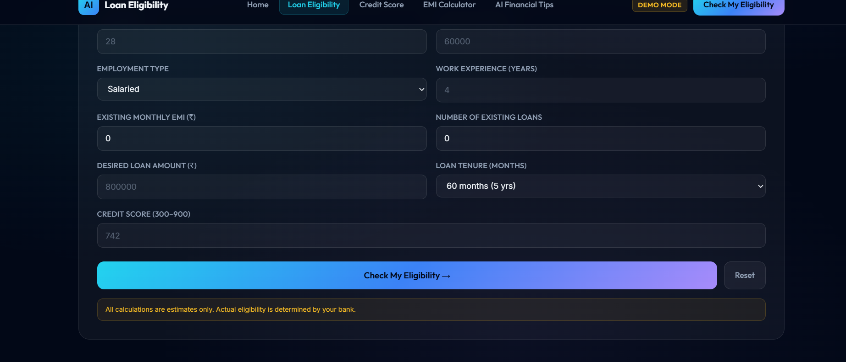
Figure 3. Loan Eligibility Checker – Calculation Controls and Disclaimer

4.2 Credit Score Analyzer
The Credit Score Analyzer provides an interactive view of the user's credit score and explains the factors that affect credit health. The uploaded documentation identifies payment history, credit utilization ratio, length of credit history, credit mix and other credit-related factors as important areas presented by the module.
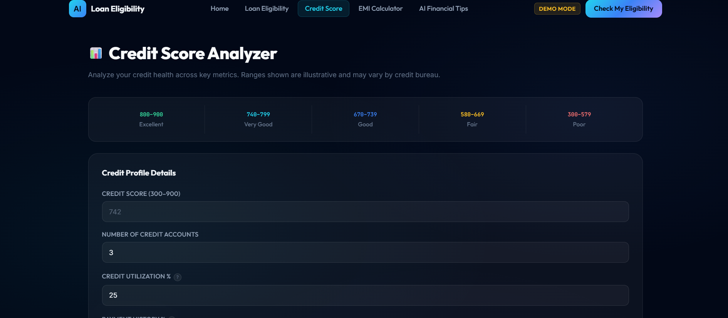
Figure 4. Credit Score Analyzer – Credit Profile Interface
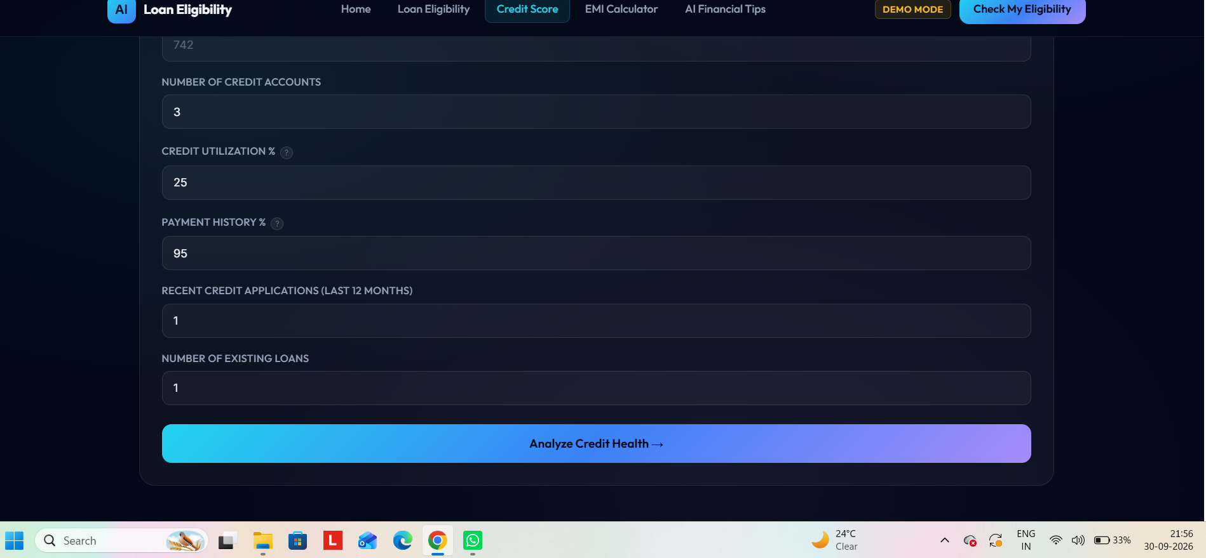
Figure 5. Credit Score Analyzer – Input and Analysis Controls

4.3 EMI Calculator
The EMI Calculator estimates monthly loan repayment using principal loan amount, annual interest rate and loan tenure. The application uses the standard EMI relationship: EMI = P × r × (1+r)^n / ((1+r)^n − 1), where P is principal, r is monthly interest rate and n is the number of monthly installments.
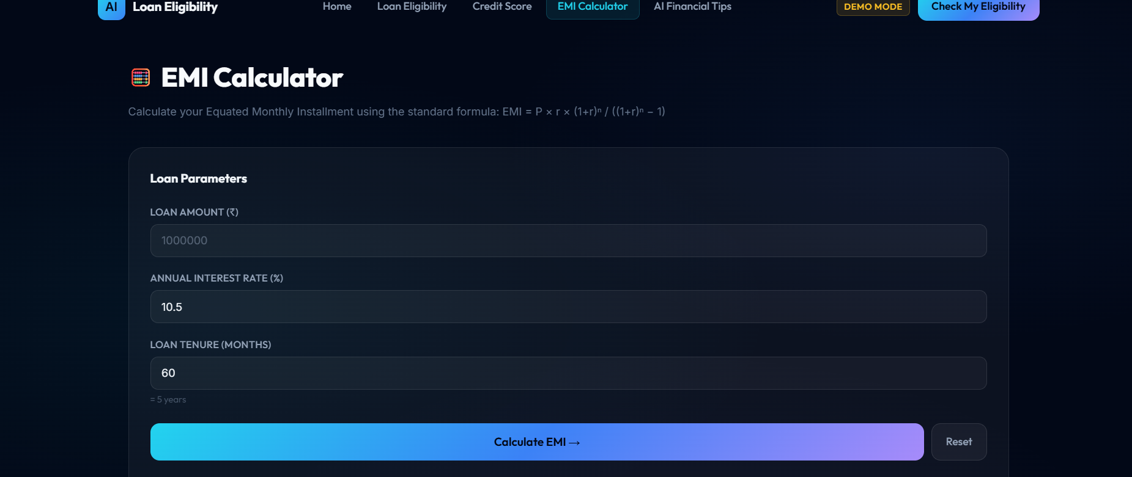
Figure 6. EMI Calculator – Loan Parameters

4.4 AI Financial Tips
The AI Financial Tips module provides educational financial guidance through Claude AI. The interface presents topics such as loan management, credit score, saving, budgeting, debt management, emergency fund and personal finance. The user can select a topic and generate guidance.

Figure 7. AI Financial Tips – Topic Selection and AI Guidance Area
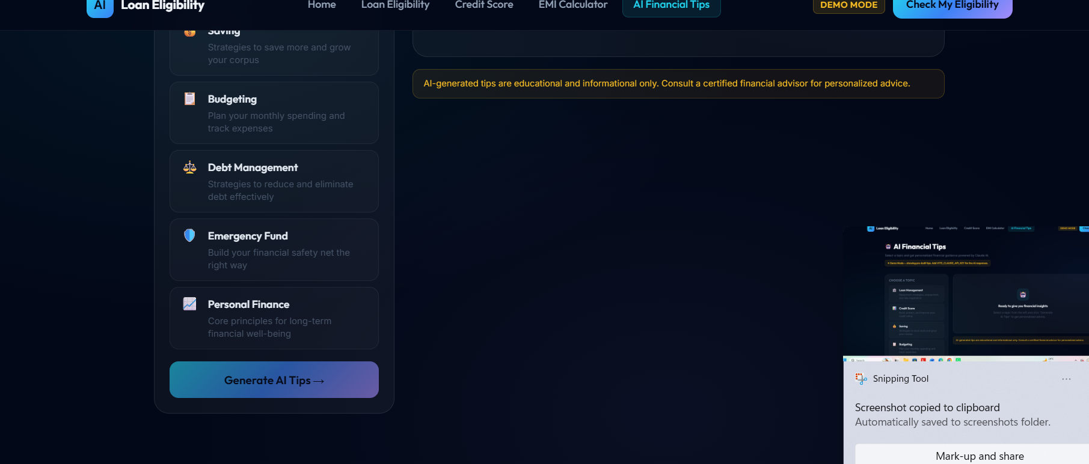
Figure 8. AI Financial Tips – Extended Topic List and Generate Control

5. Project Scenarios

Scenario 1 – User Checking Loan Eligibility
A salaried user enters monthly income, existing EMI obligations, employment information, requested loan amount, tenure and credit score. The BFSI rules process the inputs and present an estimated eligibility result.

Scenario 2 – User Analyzing Credit Health
A user enters or reviews credit-profile information and uses the Credit Score Analyzer to understand the score and the factors affecting credit health.

Scenario 3 – User Calculating EMI
A user enters loan amount, interest rate and tenure. The application calculates the estimated monthly EMI and presents the result visually.

Scenario 4 – User Seeking Financial Guidance
A user selects a financial topic and requests AI-generated guidance. Claude AI processes the request and returns beginner-friendly educational information.

5.1 Example User Journey
- Open the AI Loan Eligibility Checker home dashboard.
- Navigate to Loan Eligibility and enter the applicant financial profile.
- Run the eligibility calculation and review the estimated result.
- Open Credit Score Analyzer to inspect credit-related indicators.
- Use EMI Calculator to estimate monthly repayment for a chosen loan.
- Open AI Financial Tips and generate guidance for a selected financial topic.
- Where configured, store relevant user inputs/results through Google Sheets integration.

6. Project Workflow and Task Planning

Milestone 1 – Project Planning and Architecture
- Identify the financial problems that the application should solve.
- Define the four core modules.
- Design the overall application architecture.
- Define financial inputs and expected outputs for each module.

Milestone 2 – Financial Module Development
- Develop the Loan Eligibility Checker.
- Implement the Credit Score Analyzer.
- Implement the EMI Calculator.
- Develop financial result and visualization components.

Milestone 3 – AI Integration
- Integrate Claude AI.
- Design the financial advice prompt structure.
- Process user financial questions.
- Display AI-generated financial guidance.

Milestone 4 – Frontend Development
- Design the dashboard.
- Implement the dark glassmorphism interface.
- Develop responsive financial cards.
- Implement interactive forms and buttons.
- Integrate all four modules into the dashboard.

Milestone 5 – Testing and Demonstration
- Test loan eligibility calculations.
- Test credit score visualization.
- Test EMI calculations.
- Test AI Financial Tips.
- Verify navigation between modules.
- Verify overall user interface and responsiveness.

6.1 Development Flow
The project follows a modular development flow: requirements → architecture → financial modules → AI integration → frontend integration → testing → demonstration. This structure mirrors the milestone organization described in the uploaded BFSI documentation.

7. User Interface and Screens
The interface follows a consistent dark glassmorphism visual style. The screenshots supplied with the project show the actual working pages and navigation states. The home dashboard emphasizes the four integrated tools and presents an example eligibility profile. The internal pages use the same navigation, cards, typography and gradient action buttons.
Figure 9. Home Dashboard – Integrated Financial Overview
Figure 10. Loan Eligibility – Financial Profile Form
Figure 11. Credit Score – Analyzer Interface
Figure 12. EMI Calculator – Loan Parameter Interface
Figure 13. AI Financial Tips – Topic Selection

8. AI Integration and Data Handling

8.1 Claude AI Integration
Claude AI is integrated to extend the platform beyond fixed calculations. The AI component is primarily used for financial guidance and can process a user's financial question or selected topic to generate understandable, educational suggestions.
- Receives relevant user context or a selected financial topic.
- Processes the request using the configured Claude AI integration.
- Returns generated financial guidance in the application interface.
- Should clearly distinguish AI-generated guidance from rule-based numerical calculations.
- Should not guarantee loan approval or represent itself as a bank or regulated financial institution.

8.2 Demo Mode
The current interface includes a DEMO MODE indicator. When a live Claude API key is not configured, the application can use pre-built examples so that the complete interface remains demonstrable. Live AI analysis can be enabled by configuring the required environment/API setting.

8.3 Google Sheets Integration
The project description specifies Google Sheets integration for storing user data and supporting persistence across sessions. A practical implementation can use a Google Apps Script web endpoint to receive selected form data and calculated results. Sensitive API keys should not be exposed in client-side code, and only necessary data should be stored.

8.4 Privacy and Financial Disclaimer
The platform should be presented as an educational and decision-support application. Its eligibility outputs are estimates, and actual approval, interest rates and lending decisions depend on the policies and verification procedures of the relevant institution.

9. Testing and Verification
Test Case | Input | Expected Result
Loan Eligibility | Applicant financial profile | Application processes financial inputs and displays an estimated eligibility result.
Credit Score Analyzer | Credit score/profile information | Interactive score representation and relevant credit-health factors are displayed.
EMI Calculator | Loan amount, interest rate, loan tenure | Estimated monthly EMI is calculated and displayed.
AI Financial Tips | User topic/question | Claude AI or demo-mode logic generates and displays financial guidance.
Navigation | Clicks across Home, Loan Eligibility, Credit Score, EMI and AI Tips | Correct module/page opens without broken navigation.
Responsiveness | Desktop, tablet and mobile viewport | Layout, cards, forms and navigation remain usable.
Validation | Blank/invalid/negative inputs | User receives a clear validation message and calculation is prevented where appropriate.

9.1 Result of Verification
The supplied application screenshots demonstrate that the four major modules are implemented as separate interactive sections with a consistent navigation system and visual language. The Loan Eligibility, Credit Score, EMI Calculator and AI Financial Tips interfaces are all represented in the provided screenshots.

10. Results and Discussion
The completed platform demonstrates the integration of financial calculations, user-interface design and AI-assisted financial guidance in one web application. The home dashboard provides an immediate overview, while dedicated pages allow the user to work with each financial tool.
- Unified access to four financial utilities.
- Interactive applicant financial profile and estimated eligibility.
- Credit score visualization and factor-based analysis.
- Standard EMI calculation from loan parameters.
- Claude AI-assisted financial guidance.
- Dark glassmorphism dashboard and responsive layouts.
- Demo mode for presentation when live AI credentials are unavailable.
- Google Sheets integration specified for persistence and transparency.

10.1 User Experience
The design uses large financial values, clear section headings, glass-style cards, highlighted action buttons and consistent navigation. This presentation is intended to make financial information easier to understand for users who may not have a technical or financial background.

10.2 Demonstration Screens
Figure 14. Home Dashboard Demonstration
Figure 15. EMI Calculator Demonstration

11. Limitations and Future Scope

11.1 Current Limitations
- Loan eligibility is an estimate based on configured rules and user-entered data; it is not a bank approval decision.
- Credit-score ranges and health indicators are illustrative and can vary by credit bureau/model.
- AI guidance is educational and should not be treated as personalized regulated financial advice.
- Live Claude functionality depends on correct API configuration.
- Google Sheets persistence depends on correct endpoint/configuration and network availability.

11.2 Future Enhancements
- User authentication.
- Financial profile history.
- Loan comparison.
- Support for multiple loan types.
- Advanced credit analysis.
- Financial report generation.
- Multi-language support.
- Personalized financial dashboards.
- Database integration.
- More advanced AI-based financial planning.

12. Conclusion
The AI Loan Eligibility Checker is an AI-powered BFSI web platform that brings loan eligibility estimation, credit score analysis, EMI calculation and AI financial guidance into a single interface. The project combines HTML, CSS and JavaScript with BFSI rule-based calculations and Claude AI integration, while the current project description also specifies Google Sheets for user-data persistence.
The uploaded BFSI documentation describes the same core architecture, objectives, module structure, scenarios, workflow, testing approach and future scope. The supplied application screenshots further demonstrate the implemented user interface for the Home Dashboard, Loan Eligibility Checker, Credit Score Analyzer, EMI Calculator and AI Financial Tips pages.
Overall, the project demonstrates how modern web technologies and AI can be combined to build an interactive financial decision-support application. The system is suitable as an academic project and can be extended in the future with authentication, historical profiles, richer financial analytics, database integration and more advanced AI planning.

Project Disclaimer
This application provides educational estimates and AI-generated financial information. Loan eligibility, interest rates, credit decisions and approvals are determined by individual financial institutions and may vary according to their policies, verification processes and applicable requirements.

References / Project Sources
1. Uploaded project document: “BFSI Final Documantation.docx” (15-page project documentation supplied for reference).
2. Current project application screenshots supplied with this documentation request.
3. Project implementation stack: HTML5, CSS3, JavaScript, Claude AI integration and Google Sheets integration, as specified in the project description.

